**4G UFI/MIFI PORTABLE ROUTER**

**USER MANUAL**

**1.Brief Introduction**

This product offers secure internet sharing service to multiple terminal users. WiFi devices(Smart phones, Tablets, PCs) can get access to internet through this device, enjoy 4G/3G/2G high speed services. The connection process depends on the system of each WiFi device, please follow the prompting messages.

**PC get access to internet by 4G/3G/2G.**

When connect the device with USB cable to get access to internet, please follow the prompting messages.

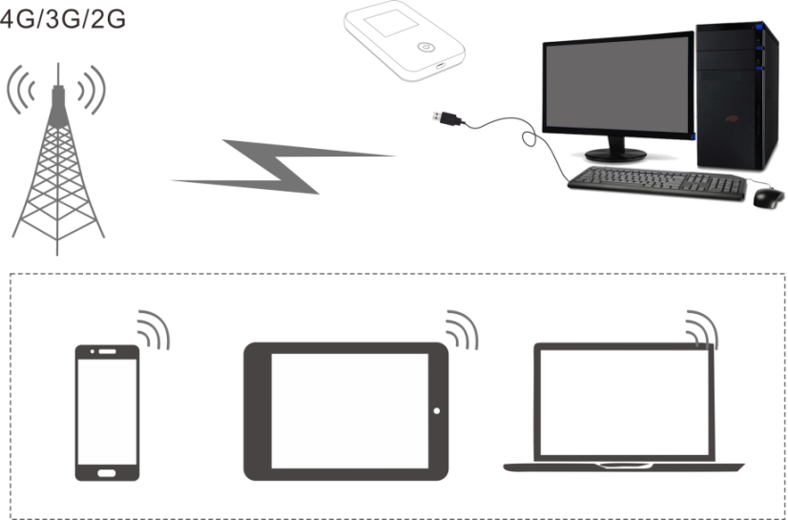

**2.Product Introduction**

Appearance (UFI)

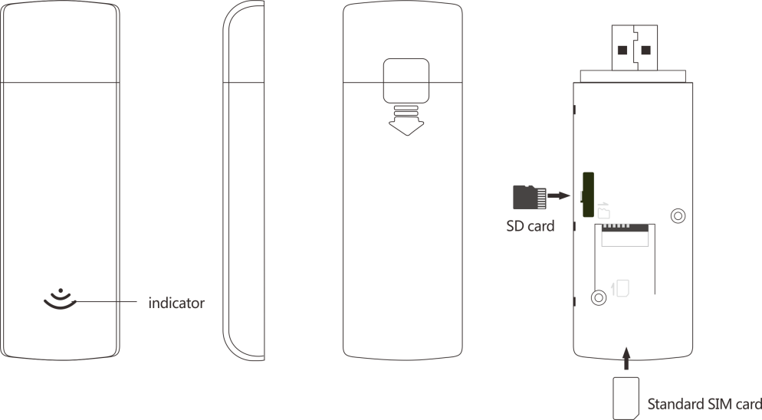

**Installation**

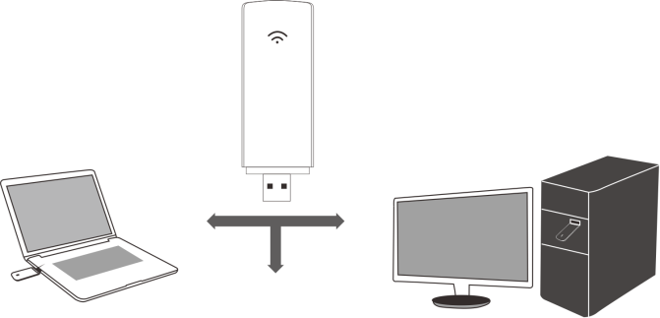Method 1: Connect it to PC, tablet via USB port. Method 2: Connect it to power bank, car charger, adapter via USB port.

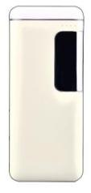

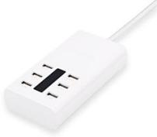

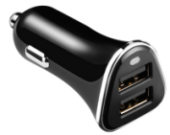

PC, tablet USB port car charger, powerbank, adapter USB po

**LED indicator lights**

LED indicator lights can show the device working status visually.

|  |  |  |  |  |
| --- | --- | --- | --- | --- |
| Color of the light | Network registered | 3-second flashing | 2-second flashing | 1-second flashing |
| Green | 4G LTE | Network registered, not connected | WIFI started, network registered, not connected | WIFI started,  Network registered and connected |
| Blue | HSPA+ | Network registered, not connected | WIFI started, network registered, not connected | WIFI started,  Network registered and connected |
| Purple | EVDO |
| Yellow | GSM/EDGE/CDMA 1X | Network registered, not connected | WIFI started, network registered, not connected | WIFI started,  Network registered and connected |
| Red | Network not registered | Network not registered(check (U)SIM status) | WIFI started,  Network  not registered |  |

**Appearance (LCD)**

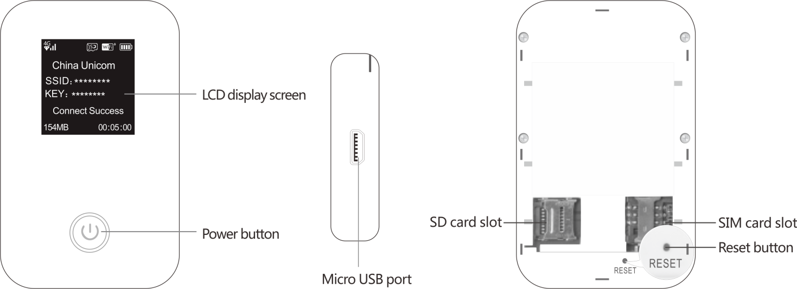

**Item Introduction**

LCD display screen To show the current status of the deviceReset

Power button Turn on/off device(Long press 3s to turn on, 5s off, 10s to force shutdown)

Micro USB port Connect to charger, PC to charge device

SD card slot Standard SD card slot(up to 32GB）

SIM card slot Standard SIM card slot

Reset button Reset button, long press for 5s to restore factory setting(click to reboot the device)

**Display Screen**

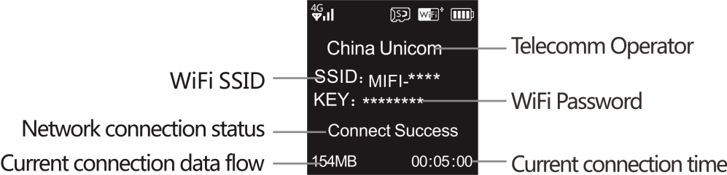

LCD display screen status specification

Indicator explanationF:\MF925S说明书\说明书\1.jpg1 Indicator explanation

Connect to TE TDD/LTE FDD 4G network F:\MF925S说明书\说明书\2.jpg2 Connect to TD-SCDMA/WCDMA 3G network

F:\MF925S说明书\说明书\4.jpg4F:\MF925S说明书\说明书\3.jpg3

Connect to EDGE 2G network SD card inserted

F:\MF925S说明书\说明书\5.jpg5

WiFi connection status(The figure means the number of the current WiFi users)

F:\MF925S说明书\说明书\7.jpg7F:\MF925S说明书\说明书\6.jpg6F:\MF925S说明书\说明书\9.jpg9F:\MF925S说明书\说明书\8.jpg8

Power status(each unit equals 25%)

**Appearance(LED)**

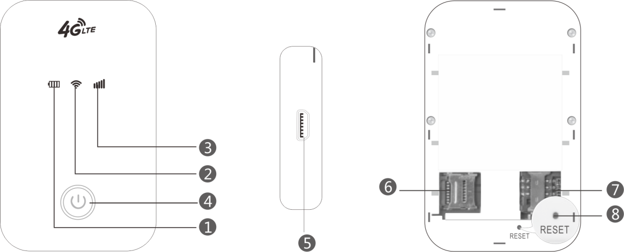

**Numbered Item project**

1 Battery Level Indicator Show the current battery level status

2 WIFI Indicator Show current WIFI connection status

3 Network Signal Indicator Show current network status

4 Power On/Off To turn on/off or wake the device

5 Micro USB Port To charge the battery, or connect to computer

6 Standard SD card slot(up to 32GB) SD card slot

7 SIM card slot Standard SIM card slot

8 Reset Button Reset button, long press for 5s to restore factory setting(click to reboot the device)

**LED indicator lights**

LED indicator lights can show the device working status visually.

|  |  |  |  |
| --- | --- | --- | --- |
| Color of the power light | Blue | Red | Purple |
| Electric quantity without charge <25% |  | Red always on |  |
| Electric quantity without charge≥25%－95% | Blue always on |  |  |
| Electric quantity without charge 95%－100% |  |  | Purple always on |
| Charge in | Blue 2 seconds flashing |  |  |
| Full power |  |  | Purple always on |
| Sleep | off | off | off |

|  |  |  |  |  |
| --- | --- | --- | --- | --- |
| Color of the WIFI light | WiFi not started | WiFi nomal start | User access | Sleep |
| Blue | WiFi light off | Blue 2 seconds flashing | Blue always on | WiFi light off |

|  |  |  |  |  |
| --- | --- | --- | --- | --- |
| Color of the sigal light | Network registered | 2-second flashing | Constant light | Sleep |
| Green | 4G LTE | Network registered, but not connected | Network registered and connected | Off |
| Blue | HSPA+ | Network registered, but not connected | Network registered and connected | Off |
| Purple | EVDO | Network registered, but not connected | Network registered and connected | Off |
| Yellow | GSM/EDGE/CDMA 1X | Network registered, but not connected | Network registered and connected | Off |
| Red | No service | Search network | No (U)SIM card found | Off |

**3.Usage Introduction**

**Insert SIM card**

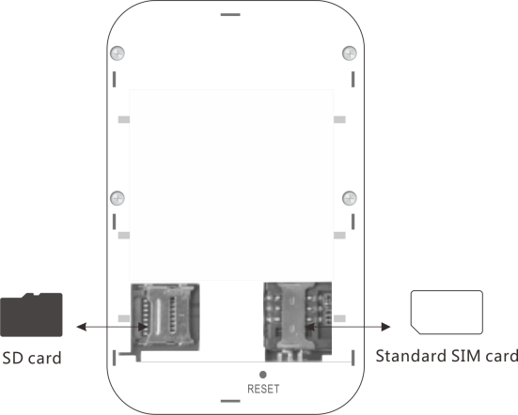

1. When inserting the SIM card, please follow the right direction as shown on the image.

2. Same with SD card.

**Charging**

If the battery has not been used for a long time or the battery runs out, when charge it again, the device may not be able to be turned on at once, it is normal, please keep charging it for a while and turn it on later.

Method 1: Connect to socket with USB charger Method 2: Connect to computer with USB cable

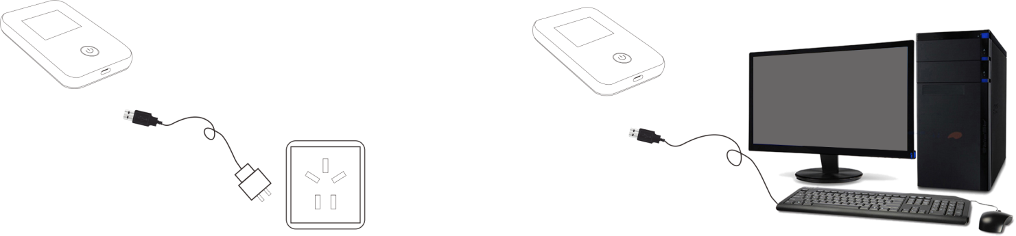

Tip:

When have to use your mobile phone or tablet while they are out of power, you can use our product as a power bank to charge your mobile phone or tablet through the USB port(output 5V-1A).

**4.WiFi Connection**

**WiFi account**

When terminal users connect to this device at first time, users need to find SSID(WiFi name), which is MIFI-**** ,type in the password：1234567890 (see detailed info on the label at the back of the device)

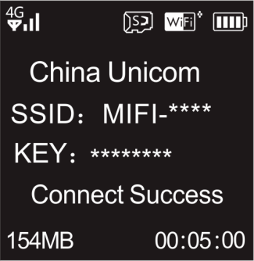

Check SSID and password on LCD screen

Note:

Log in the management interface.【http://192.168.0.1】and enter to set a memorable SSID and more secure Wi-Fi password.

**Windows 7**

1.Click Start>Control Panel>Network and Internet>Network and Sharing Center>Connect network

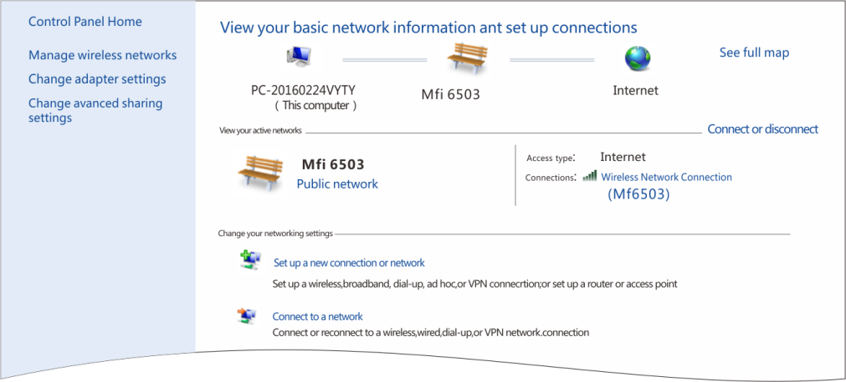

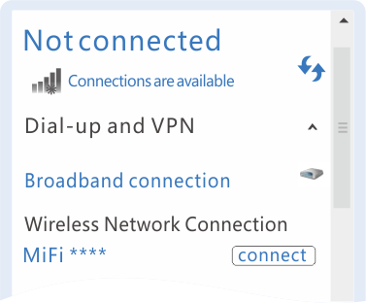2.Choose the right SSID of the device, and click connect. 3. Type in the correct password and connect.

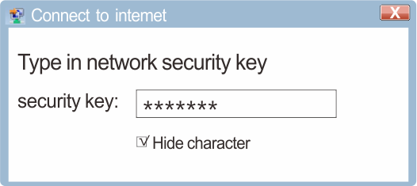

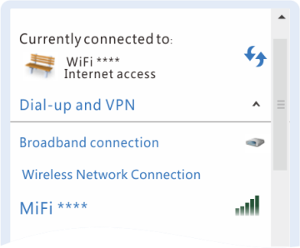4. Wait for a while till it is connected.

Tip: Before connecting WiFi, please make sure the PC(or other devices) has the wireless network card, as shown on the image, click the wireless network list, if it shows the list, then the wireless network card works, otherwise you need to check your wireless network card.

**Android Mobile phone**

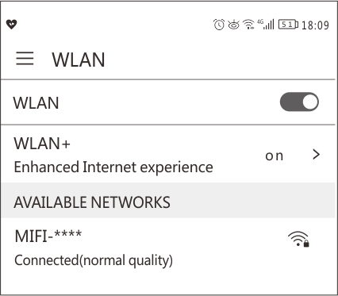1. Setting, click WLAN, switch on WLAN 2. Choose the right SSID

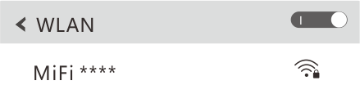

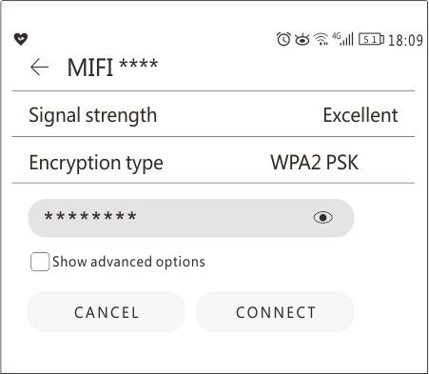3.Type in the correct password and connect. 4. Wait for a while till it is connected.

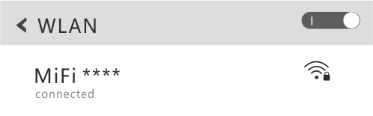

**5. Backstage Configuration**

**Log in the WEB management interface**

**Mobile Phone:**

1. Make sure the wifi connection between mobile phone and the wifi device is normal.
2. Open the browser, type in <http://192.168.0.1,> and enter, if the IP address is in conflict with other IP address, the device will upgrade the IP address automatically.
3. Type in the password, and log in the management interface, the default password is admin.
4. On quick setup interface, user can set up the Profile configuration and the WLAN configuration, please follow the instruction on the screen to quick setup the device. On next page, click “next page”to continue or “back”to go back to the previous page. If user wants to end it without saving these settings, please click “cancel”.
5. Go back to the front page, click “more”to do more settings.

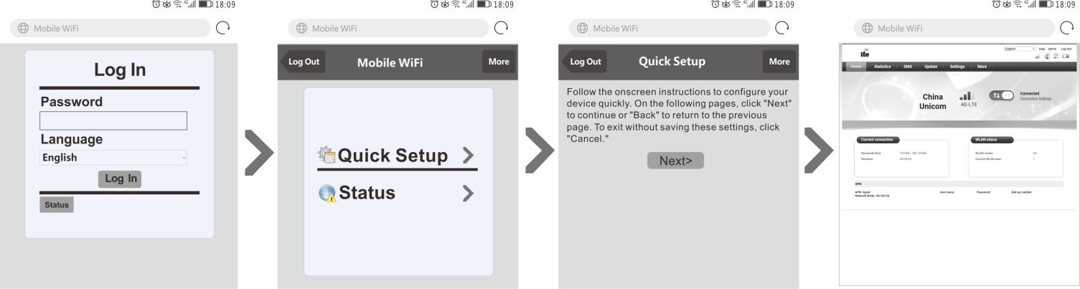

**PC:**

1. Make sure the wifi connection between mobile phone and the wifi device is normal.

2.Open the browser, type in <http://192.168.0.1,> and enter, if the IP address is in conflict with other IP address, the device will upgrade the IP address automatically.

3.Type in the password, and log in the management interface, the default password is admin.

4.On quick setup interface, user can set up the Profile configuration and the WLAN configuration, please follow the instruction on the screen to quick setup the device. On next page, click “next page”to continue or “back”to go back to the previous page. If user wants to save these settings, please click”Completed”.

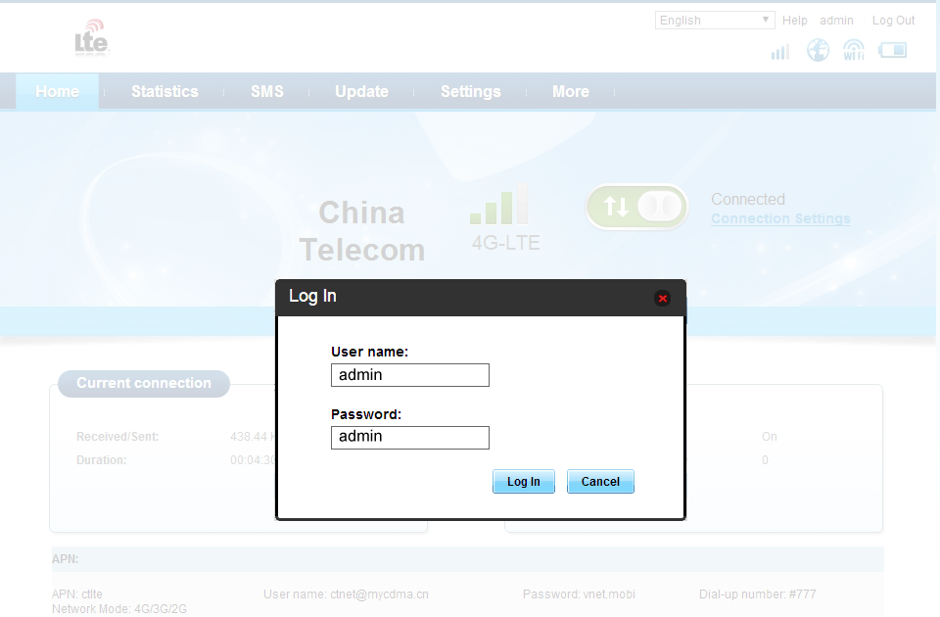

**WIFI Security Settings**

You can follow the below steps to set a memorable SSID and more secure WiFi password Log in WEB UI>WLAN configuration>modify SSID>type in new password>click to save it.

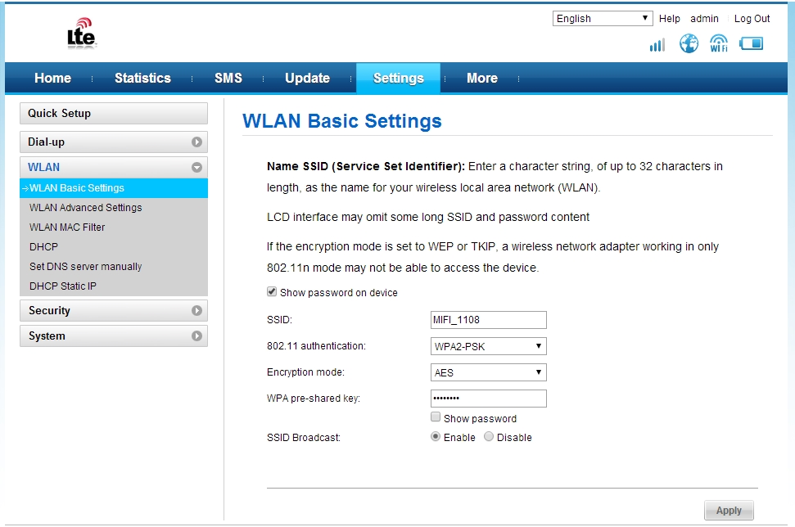

**Restore the factory setting/Reboot**

Restore the factory setting: Settings>System>Restore defaults, click restore, and it will restore factory settings.

Reboot: Settings>System>Reboot, click reboot, it will reboot.

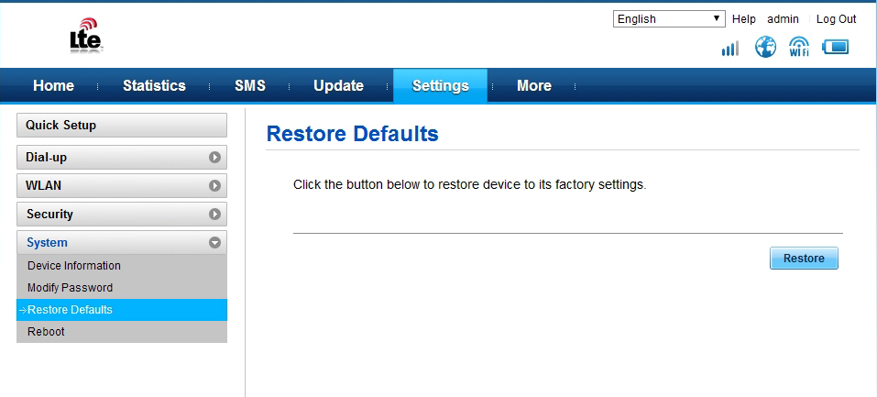

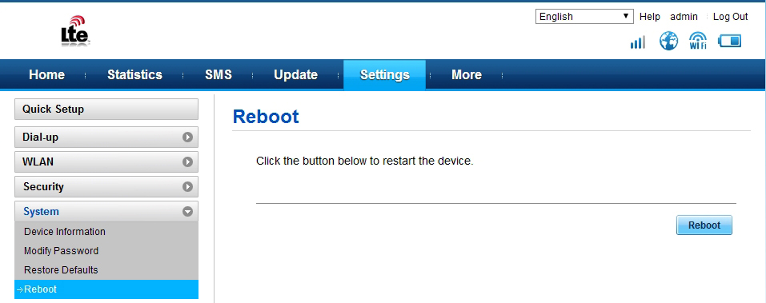

**Data Usage**

To show the current network uplink, downlink speed, the data usage and duration of this connection, the data usage and duration of this month.

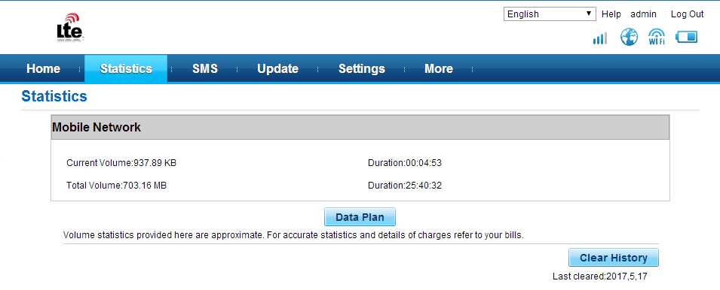

**SMS function**

Receive/delete/draft SMS functions

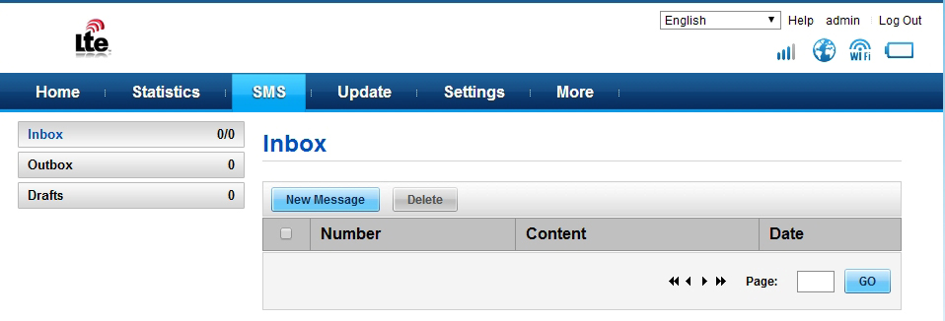

**SD card sharing**

Choose Web sharing mode/USB access only/No sharing method

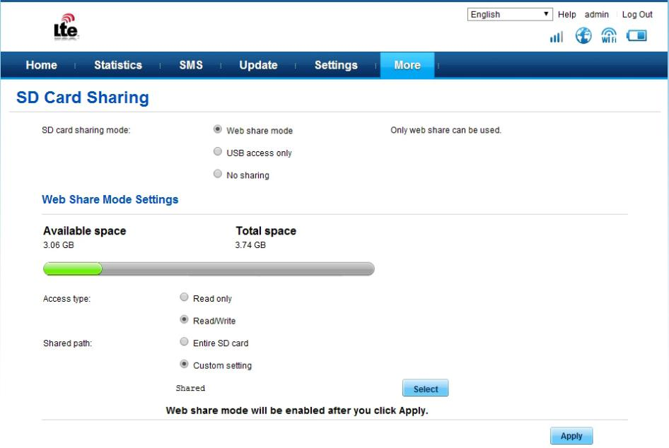

**Configuration list/Warning and notice**

**Serial Accessories Number**

1 4G wireless router 1

2 USB cable（UFI does not have it） 1

3 User manual 1

*Please don’t start it in the place where it is forbidden or it may cause interference or damages.

*When get close to high precision instruments, please turn it off, it may effect the performance of the devices(such as the embedded medical equipment)

*Please don’t put the device in the place where explosion may happen.

*Keep the device dry, keep any liquid from it to make any damage

*Don’t throw, hit the device, it will damage the PCBA and effect the performance.

*Don’t operate it with wet hands, it may cause electric shock.

*It will get hot which is normal when it is put in the place with weak signal or high temperature for a long time. It will not influence the usage and the life of it, don’t touch it with skin for a long time.

*Don’t store it in a high temperature environment, it will shorten the life of the device, damage it or make explosion.